# Week 3 — Simulation Results

This folder contains the results obtained from the LTspice simulations performed during Week 3.

The simulations were used to compare theoretical calculations with circuit behavior and to observe the operating conditions of the components.

---

# Lab 1 — Voltage Divider

## Objective

To verify the calculated output voltage of a voltage-divider circuit using different values of R2.

## Results

| R1 | R2 | Calculated Vout | Simulated Vout |
|---:|---:|---:|---:|
| 1 kΩ | 1 kΩ | 6 V | 6 V |
| 1 kΩ | 500 Ω | 4 V | 4 V |
| 1 kΩ | 2 kΩ | 8 V | 8 V |
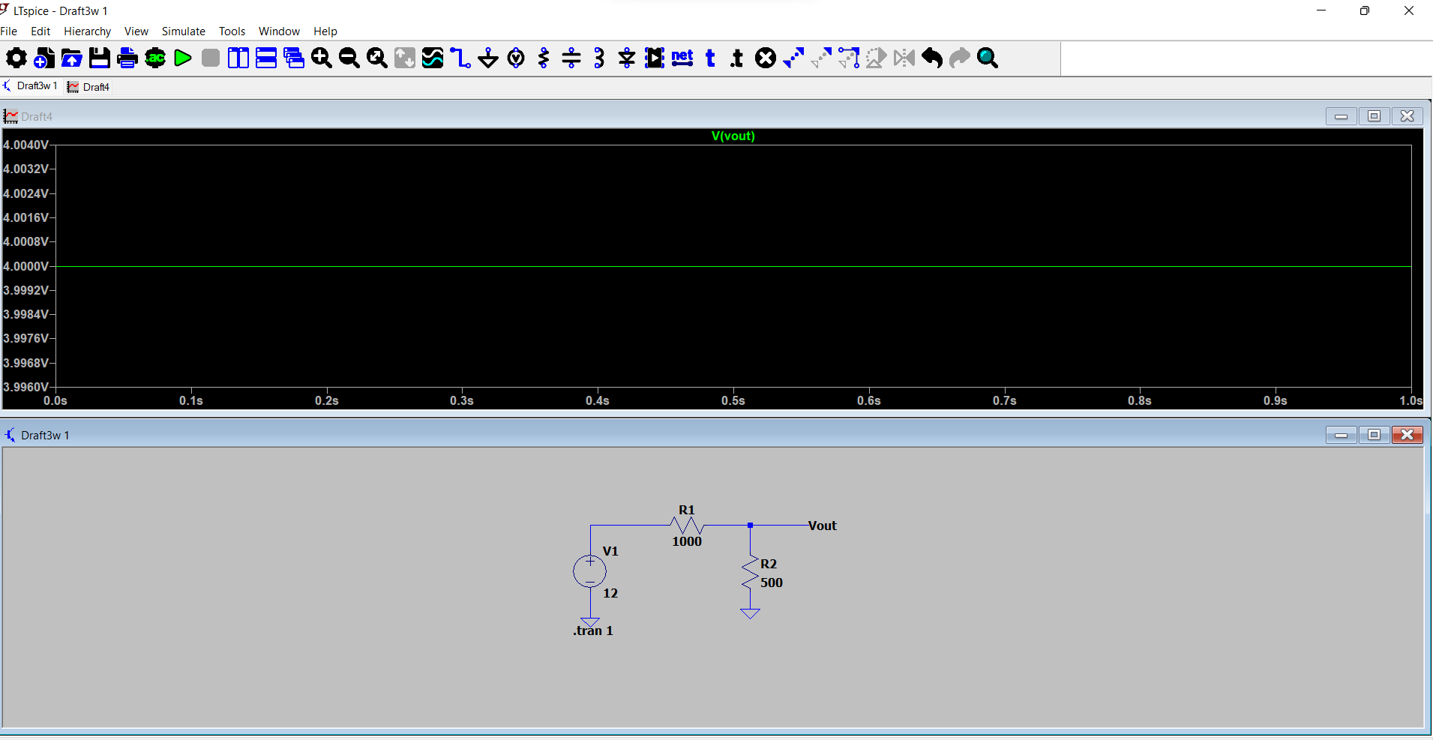
## Result

The calculated and simulated output voltages matched for all three configurations.

This confirms the voltage-divider relationship used in the calculations.

### Simulation Evidence

![Lab 1 Simulation](Lab1_Voltage_Divider_Result.png)

---

# Lab 2 — RC Charging

## Objective

To verify the calculated RC time constant and observe capacitor charging behavior.

## Circuit Parameters

- R = 1 kΩ
- C = 100 µF
- Supply = 12 V

Calculated time constant:

\[
\tau=RC
\]

\[
\tau=(1000)(100\times10^{-6})
\]

\[
\boxed{\tau=0.1s}
\]

## Simulation Results

| Time | Simulated Capacitor Voltage |
|---:|---:|
| 1τ = 0.1 s | 7.8 V |
| 2τ = 0.2 s | 10.4 V |
| 5τ = 0.5 s | ≈12 V |

## Result

The simulation demonstrated the expected exponential charging behavior of the capacitor.

The capacitor approached the 12 V supply voltage as time increased and reached approximately 12 V at 5τ in the simulation.

### Simulation Evidence

![Lab 2 Simulation](Lab2_RC_Charging_Result.png)
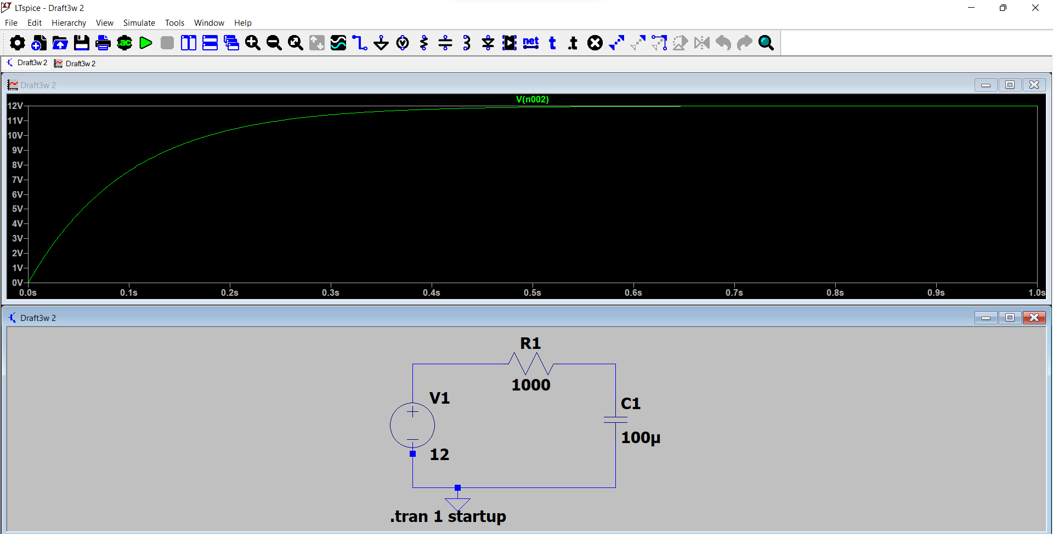
---

# Lab 3 — LED Current Limiting

## Objective

To calculate the resistor required to limit LED current and compare the calculated current with the LTspice result.

## Circuit Parameters

- Supply = 12 V
- Assumed LED forward voltage = 2 V
- Target current = 10 mA
- Calculated resistor = 1 kΩ

## Calculation

\[
R=\frac{V_S-V_F}{I}
\]

\[
R=\frac{12-2}{0.01}
\]

\[
\boxed{R=1k\Omega}
\]

## Simulation Results

| Parameter | Result |
|---|---:|
| Resistor | 1 kΩ |
| Target current | 10 mA |
| Operating current | 11.28 mA |
| Dissipating power | 8.098 mW |

## Result

The simulated operating current was 11.28 mA compared with the calculated target of 10 mA.

The difference demonstrates that the simulated LED model does not behave exactly according to the simplified 2 V forward-voltage assumption used in the calculation.

### Simulation Evidence
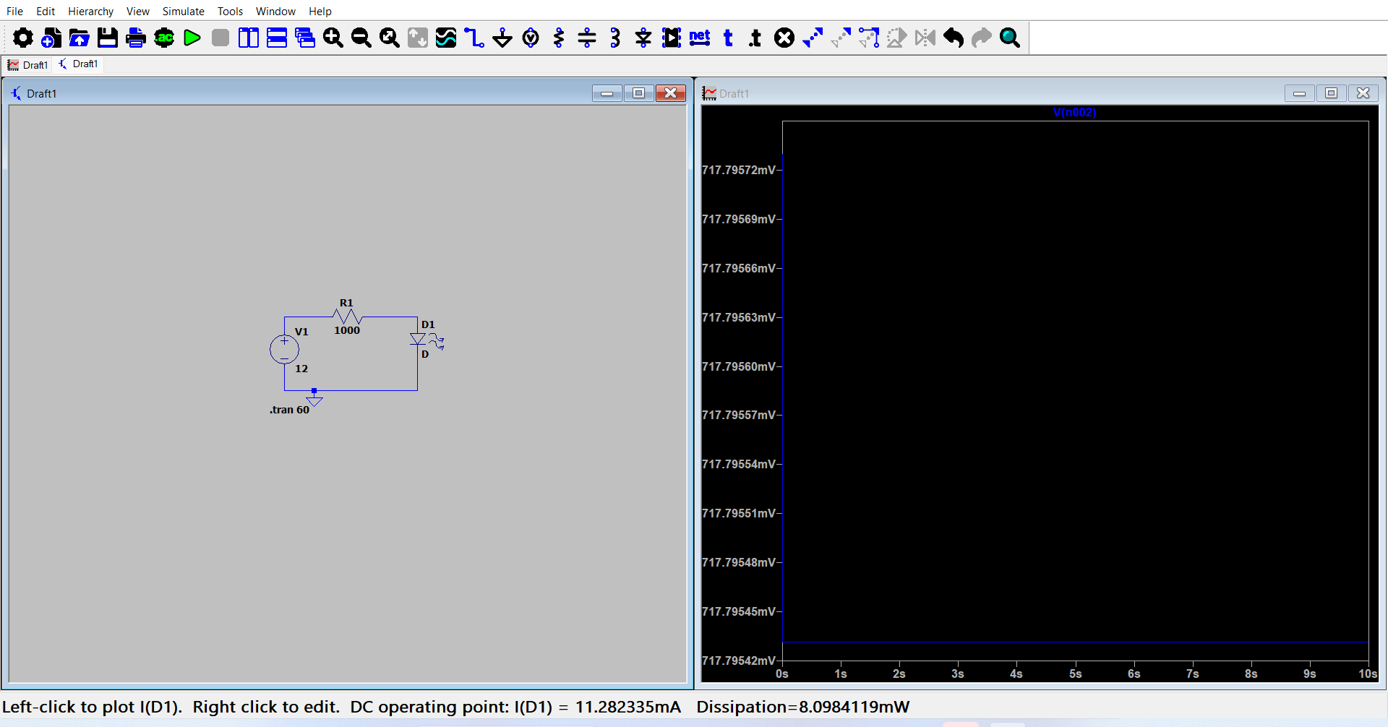
![Lab 3 Simulation](Lab3_LED_Current_Limiting_Result.png)

---

# Lab 4 — NPN Transistor Switching

## Objective

To verify the operation of a 2N2222A NPN transistor as an electronic switch.

Two operating conditions were tested:

1. Control voltage HIGH
2. Control voltage LOW

---

## ON State

### Control Voltage

\[
V_{control}=5V
\]

### Simulation Results

| Parameter | Result |
|---|---:|
| Base voltage \(V_B\) | 802.25 mV |
| Collector voltage \(V_C\) | 48.89 mV |
| LED current | 25.98 mA |
| LED power dissipation | 87.71 mW |

### Observation

The transistor turned ON when the control voltage was HIGH.

The collector voltage dropped close to ground and current flowed through the LED.

\[
Control\ HIGH
\rightarrow
Transistor\ ON
\rightarrow
LED\ ON
\]

### Simulation Evidence
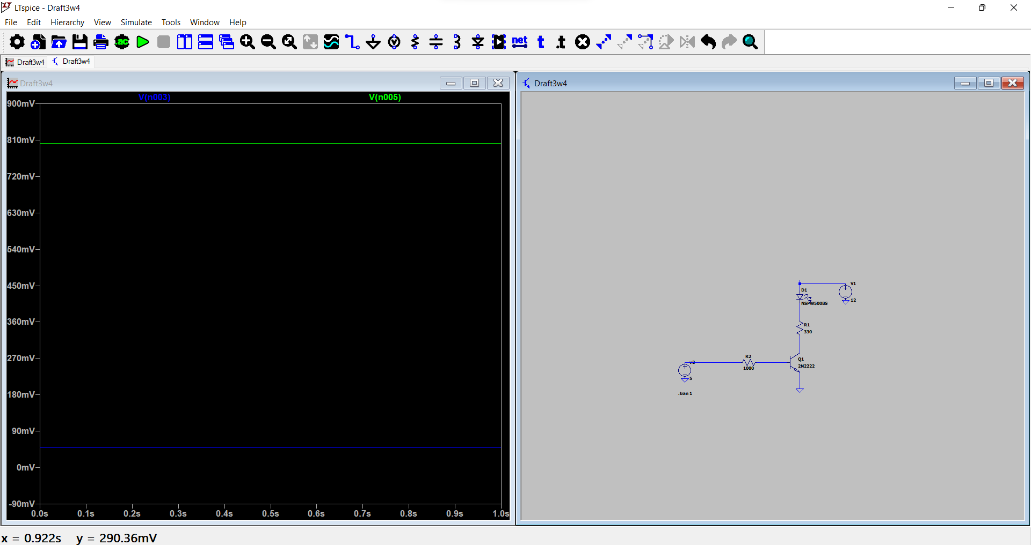
![Lab 4 ON State](Lab4_Transistor_Switching_ON_Result.png)

---

# Lab 4 — OFF State

### Control Voltage

\[
V_{control}=0V
\]

### Simulation Results

| Parameter | Result |
|---|---:|
| Base voltage \(V_B\) | 11.99 nV |
| Collector voltage \(V_C\) | 11.99 V |
| LED current | 12 pA |
| LED power dissipation | 91 fW |

### Observation

The transistor turned OFF when the control voltage was reduced to 0 V.

The LED current became effectively zero and the collector voltage rose to approximately the supply voltage.

\[
Control\ LOW
\rightarrow
Transistor\ OFF
\rightarrow
LED\ OFF
\]

### Simulation Evidence

![Lab 4 OFF State](Lab4_Transistor_Switching_OFF_Result.png)

---

# Overall Results

| Lab | Main Result | Verification |
|---|---|---|
| Lab 1 — Voltage Divider | Calculated and simulated voltages matched | ✅ |
| Lab 2 — RC Charging | τ = 0.1 s; charging behavior verified | ✅ |
| Lab 3 — LED Current Limiting | 1 kΩ resistor; 11.28 mA simulated current | ✅ |
| Lab 4 — Transistor Switching | ON and OFF states successfully verified | ✅ |

---

# Key Observation

The simulations demonstrated that theoretical calculations provide expected circuit behavior, while simulation allows those expectations to be tested against component models.

Differences between calculation and simulation were investigated rather than ignored.

The results were documented as part of the Week 3 engineering workflow:

**Calculate → Simulate → Compare → Investigate → Document**

